**LAB 04 TASKS**

**Question #01) Write a C++ program that tells the user that the number entered is less than or greater than 10?**

**Source Code:**

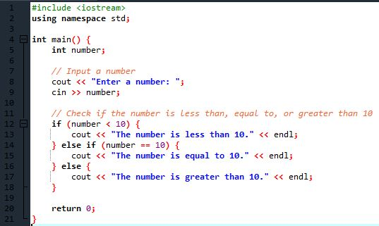

**Output:**

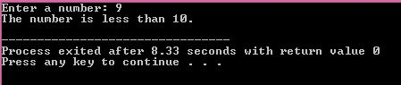

**Question #02) Write a C++ program that tells the user that the number entered is even or odd?**

**Source Code:**

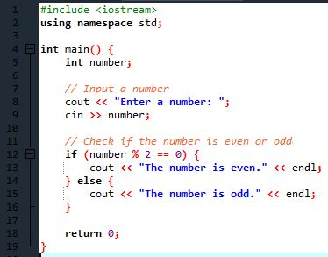

**Output:**

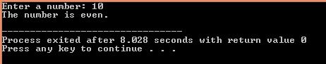

**Question #03) Write a menu driven C++ program that ask the user to choose the type in which he wants the output?**

**Either he wants to convert the entered Celsius temperature in to** **Fahrenheit or Kelvin?**

**Source Code:**

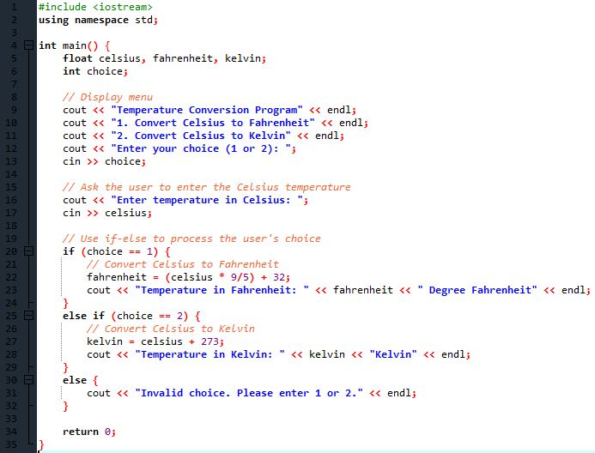

**Output:**

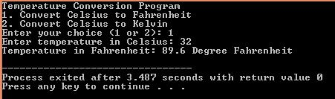

**Question #04) Write a program to compare following strings with each other and display which string is smaller.**

**string str1 = "Hello";**

**string str2 = "Hi";**

**string str3 = "Air";**

**string str4 = "Bill";**

**string str5 = "Big";**

**Source Code:**

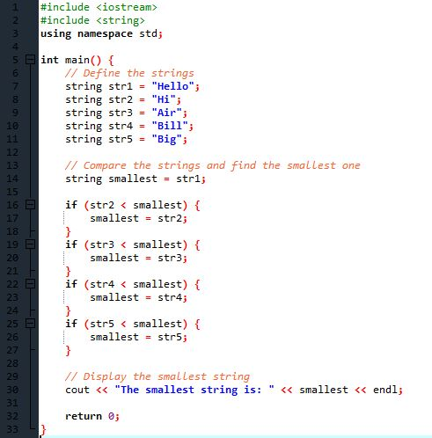

**Output:**

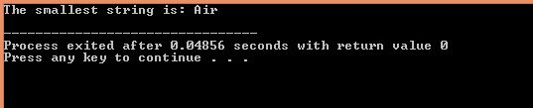

**Question #05) According to your grading system mark the user entered numbers as Grade A, B, C, D, F?**

**Source Code:**

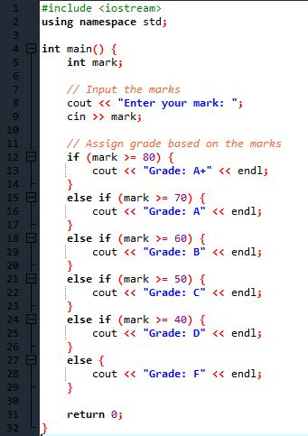

**Output:**

